How to log into Powerschool App

Step 1: Create the Powerschool account. Use the information provided on the other side of this sheet to help create your account. If you are still having trouble creating an account please contact the guidance department at 413-772-1350 x1129 or by email at amybra1@gpsk12.org

Step 2: Download Powerschool App for Android or IOS mobile device.
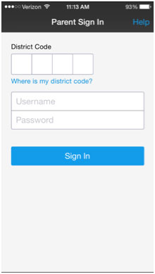
Step 3: Log into your Powerschool App using the username and password you created. You will also need our district code which is: XKJQ

